For-each loop

* It starts with the keyword **for** like a normal for-loop.
* Instead of declaring and initializing a loop counter variable, you declare a variable that is the same type as the base type of the array, followed by a colon, which is then followed by the array name.
* In the loop body, you can use the loop variable you created rather than using an indexed array element.
* It’s commonly used to iterate over an array or a Collections class (eg, ArrayList)

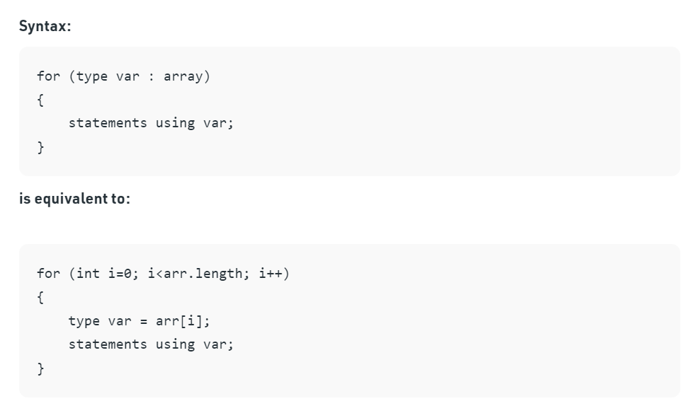

🡺Example Program

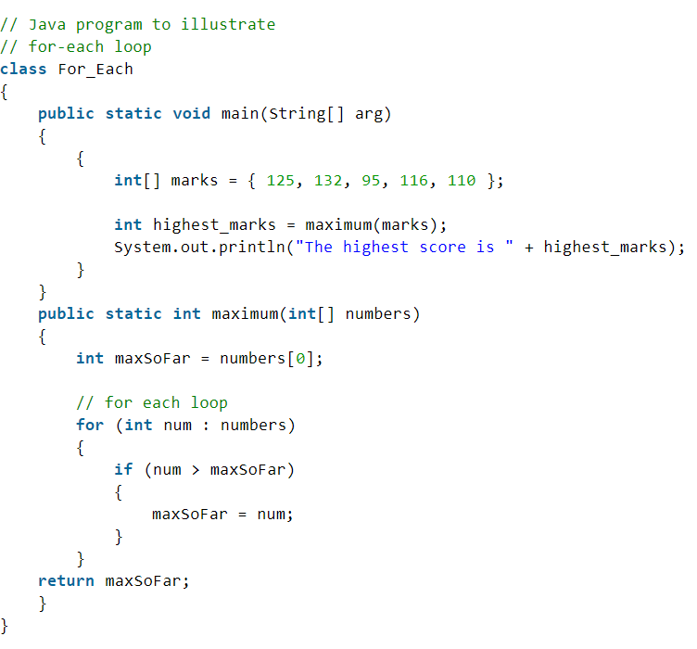

🡺Limitations of the for-each loop

1. For-each loops are**not appropriate when you want to modify the array**
2. For-each loops **do not keep track of index**. So we can not obtain array index using For-Each loop
3. For-each **only iterates forward over the array in single steps**
4. For-each **cannot process two decision making statements** at once